The home screen contains the latest news about the software.
Also you can see the expiration date of the software license in green in the upper left area of the screen.
The "START (RECOMMENDED)" button takes you to the layer settings.
With "START (PREVIOUS SETTINGS)" one skips this and can import the scan data directly.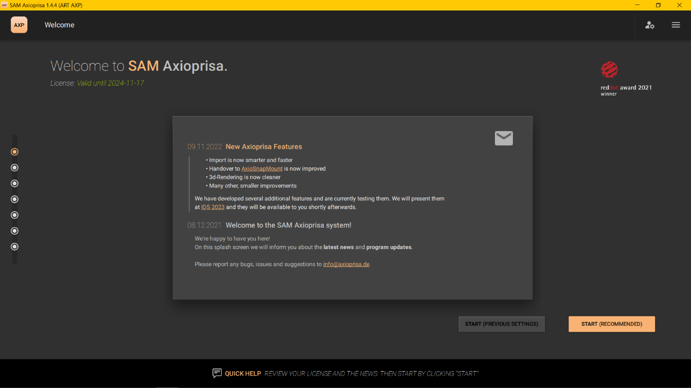

In the plane setting, one selects the facebow used and the articulator.
Other external companies will be implemented here later.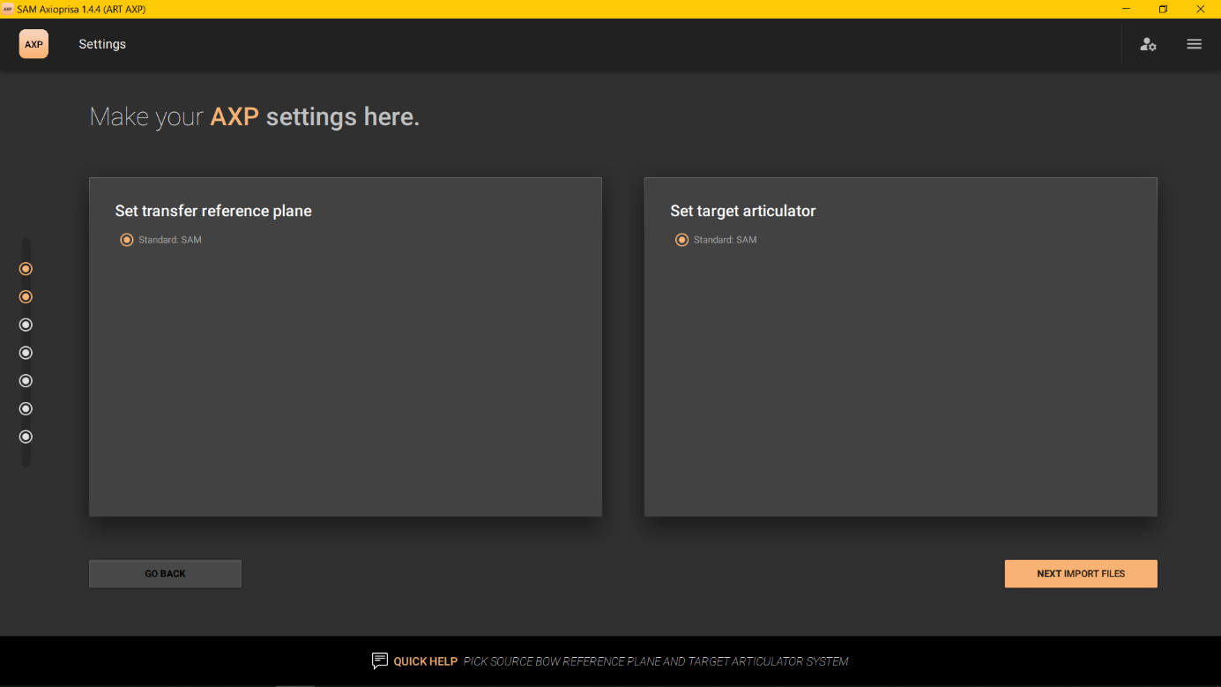
In this step the scan files will be imported. To do this, click on the "IMPORT YOUR FILES NOW" button to open the Explorer.
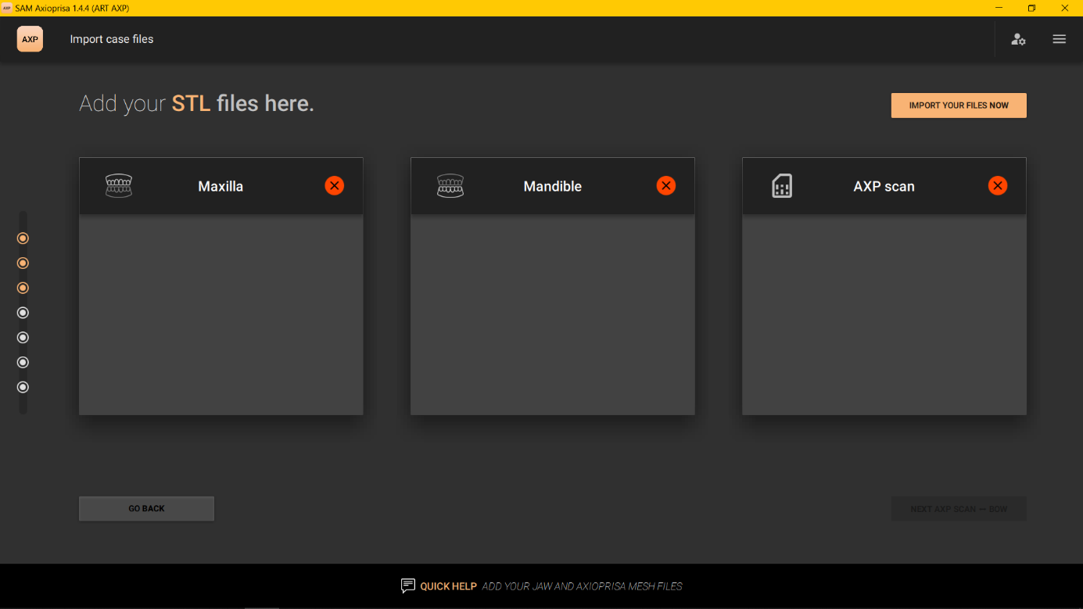

In the explorer all three files can be selected at once.
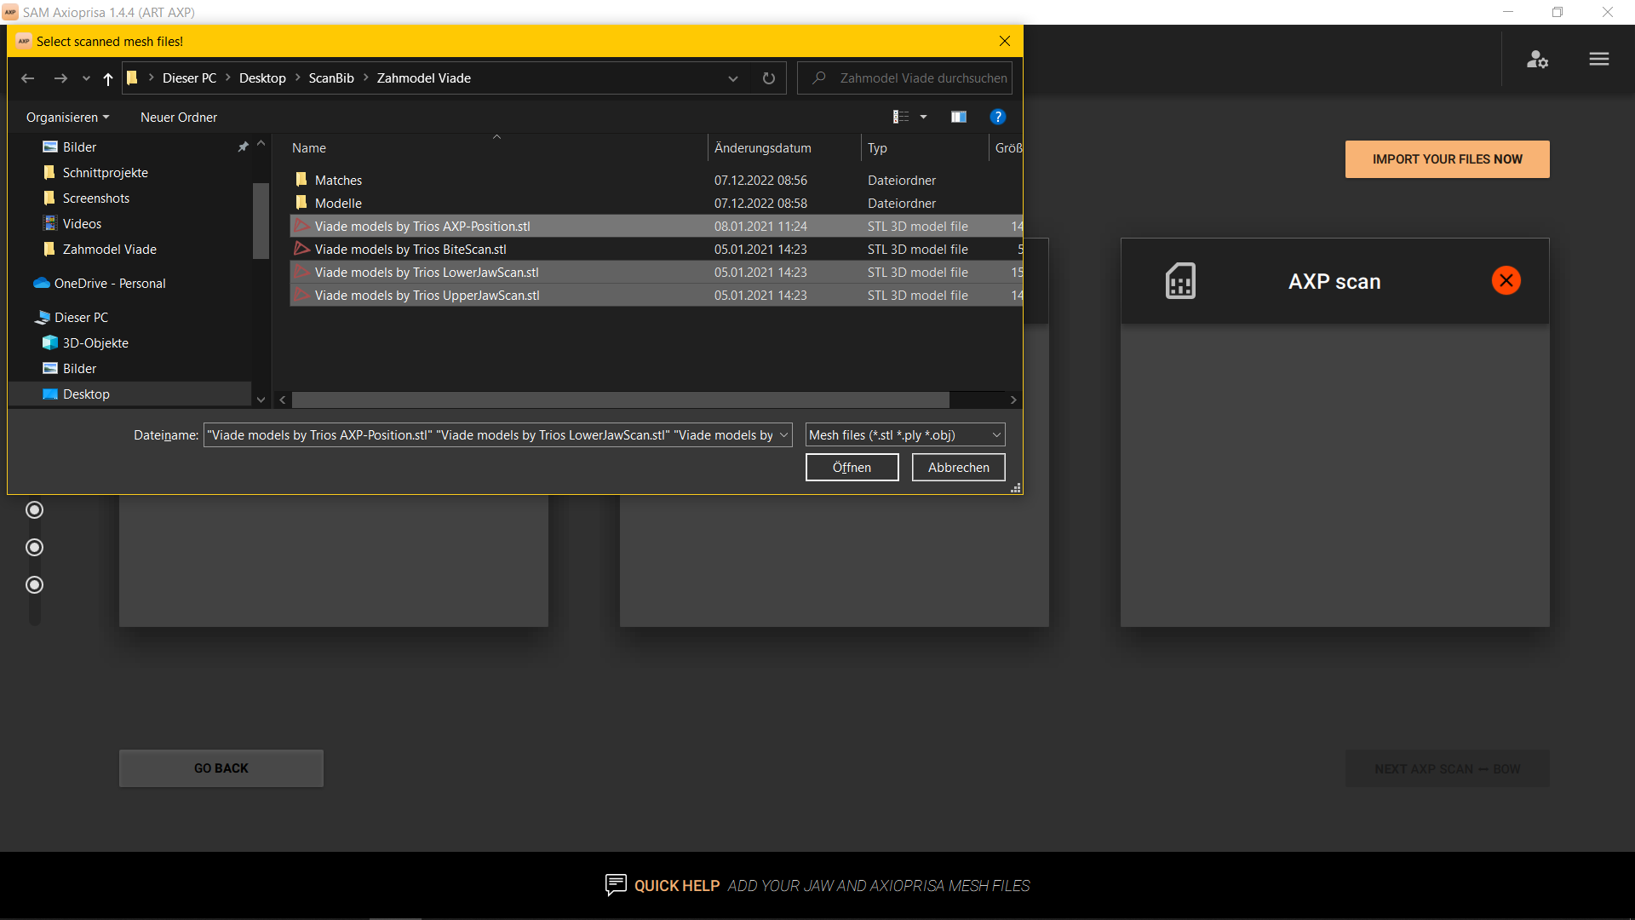

The AI sorts the scans appropriately. However, if an error occurs here, the scans can be changed with the orange buttons "SWAP WITH AXP SCAN" and "<- ->". With "NEXT AXP SCAN ↔BOW" you get to the next step.
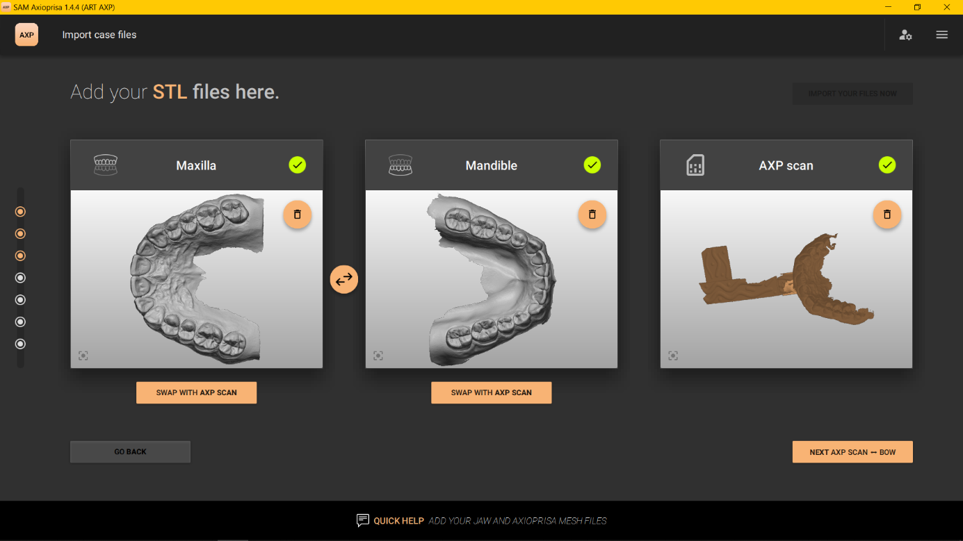

Here you assign the bite fork scan spatially. To do this, select the three round depressions on the landing pad on the bite fork scan and then confirm the fit with "FINE ALIGN THE MESHES".
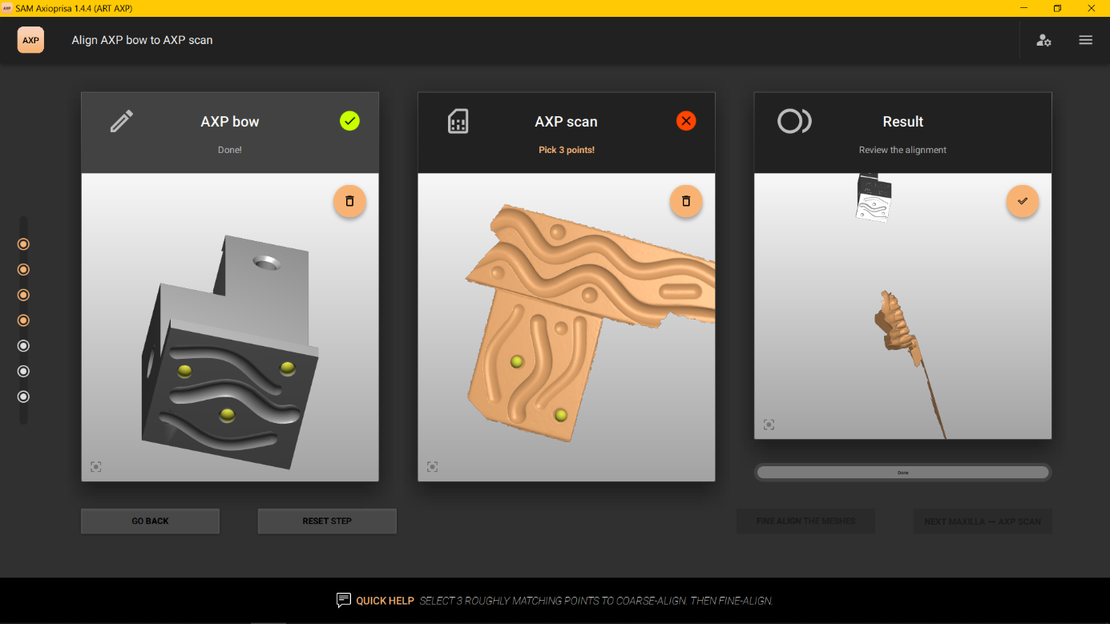

The previously selected option "FINE ALIGN THE MESHES" analyzes the surface of the scan and adapts it precisely to the virtual counterpart. NEXT MAXILLA ↔ AXP SCAN" takes you to the next step.
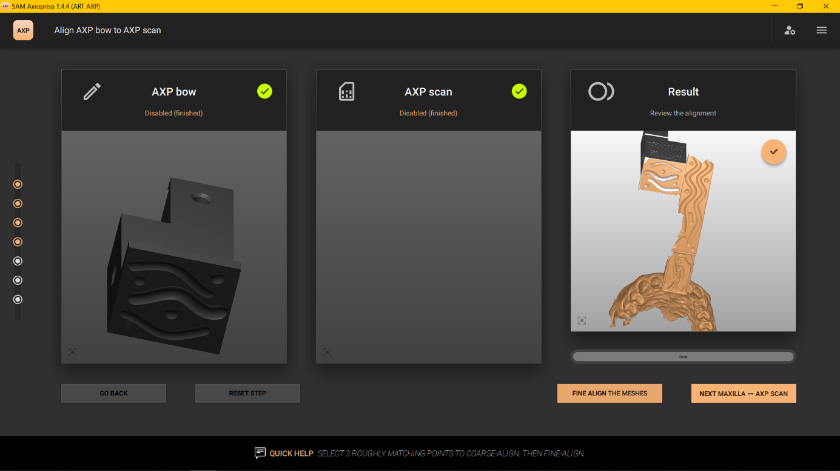

Here, you also select three points on the scans. This is done on the bite fork scan and on the upper jaw scan.
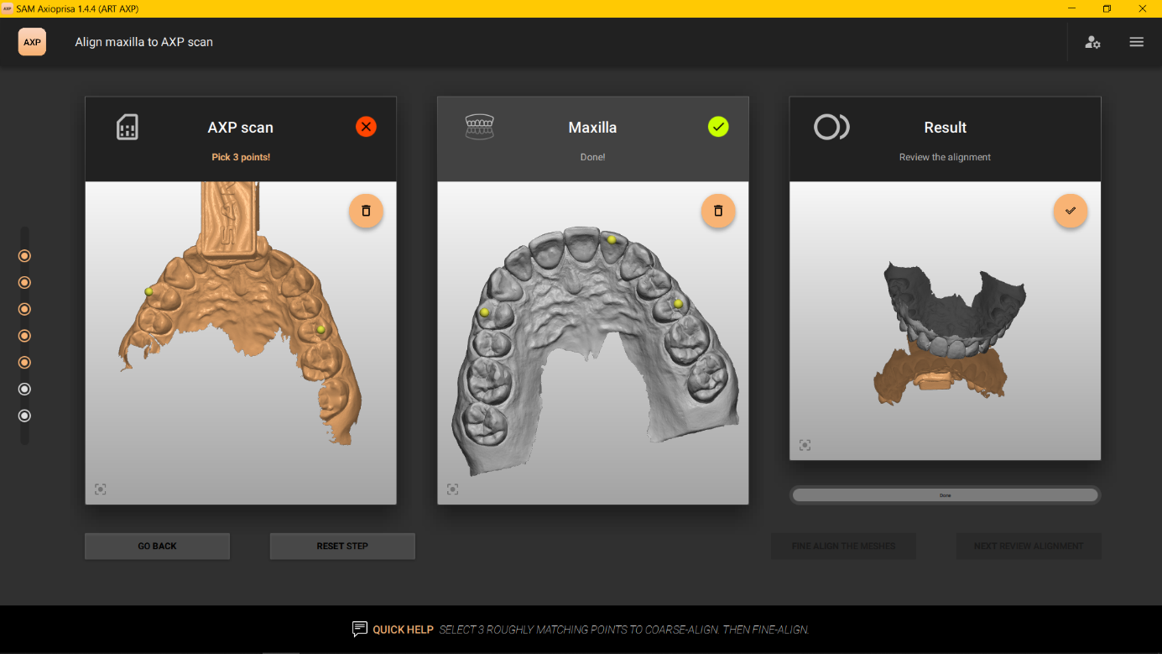

The accuracy of fit is then increased with "FINE ALIGN THE MESHES".
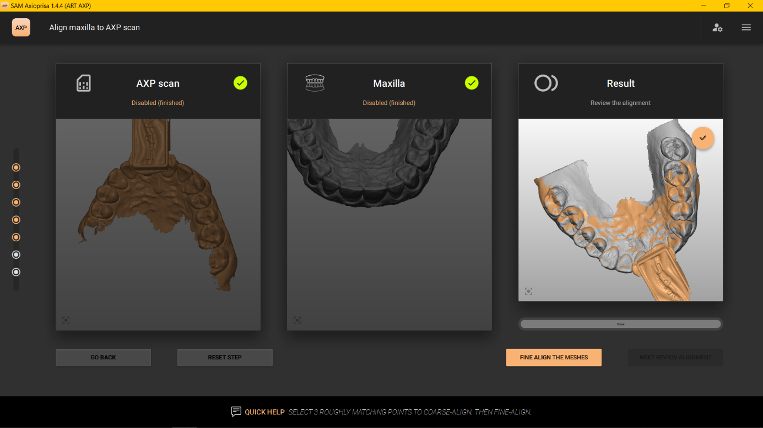

When the AI has finished adjusting the scans, confirm the result with "NEXT REVIEW ALIGNMENTS".
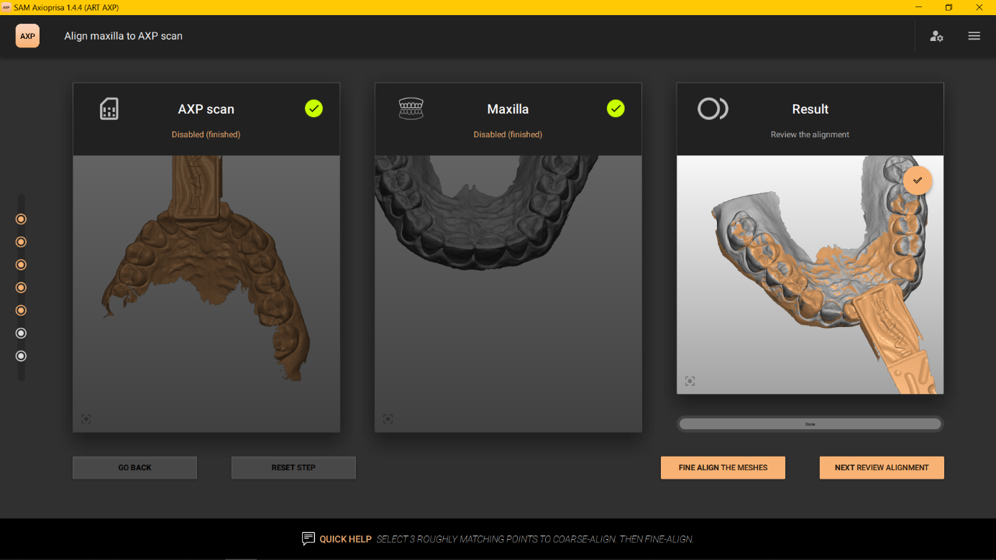

For the final check, the positioned scans are displayed again here in the articulator. If the alignment is identical to the situation on the patient, the step is ended with "OK, GO TO EXPORT".
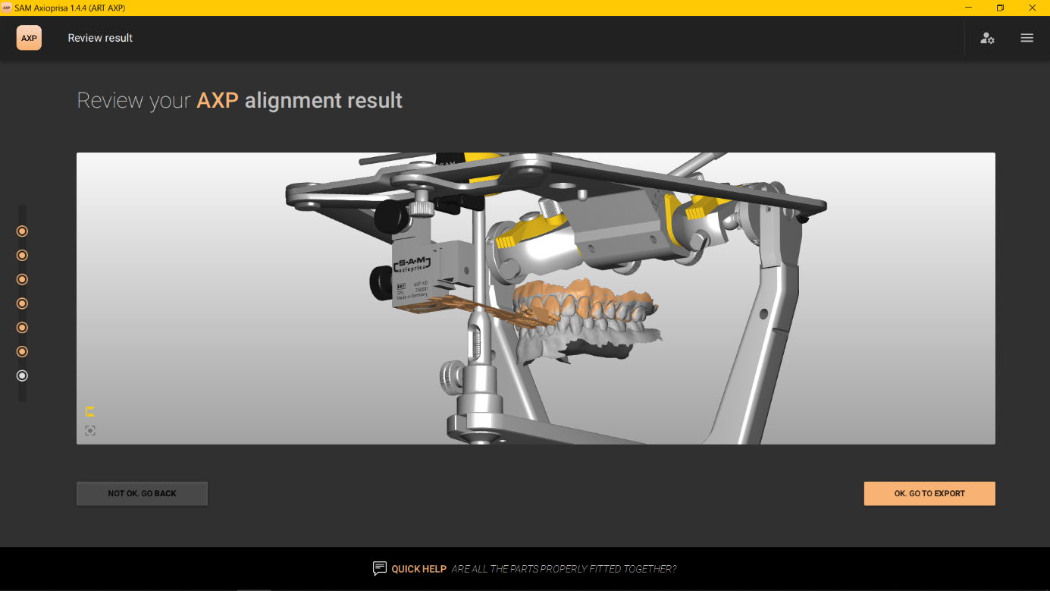

The export options in the upper column currently include the SAM, 3Shape and Exocad coordinate systems. Also the direct transfer of the datasets into AxioSnapMount is possible.
